**TEMASEK POLYTECHNIC**

**SCHOOL OF INFORMATICS & IT**

**DIPLOMA IN IMMERSIVE MEDIA & GAME DEVELOPMENT**

**AY2025/2026 APRIL SEMESTER**

**GADV (CGE2C25)**

**Introduction to Unity**

**MonoBehaviour**

To see the additional comments and resources, make sure you select **All Markup** in the **Review/Tracking** pane

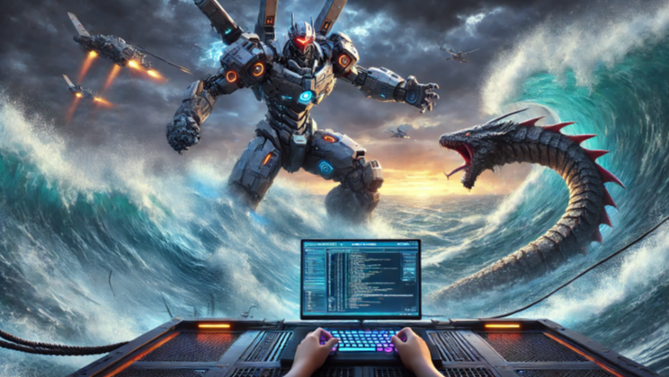

**Objectives**

I asked Chat GPT to first create, and then explain, this picture:

Explain what is happening in this image. Then try to relate it to the theme of students having to learn C# programming for Unity.

This is its response:

A sci-fi scene depicts a coder at a high-tech workstation, typing as a massive mech battles a sea serpent in stormy waters.

Fighter jets soar overhead, hinting that the coder controls the fight through programming.

This image captures the essence of learning C# programming in Unity:

* **The Programmer as Creator**: Just as the coder shapes the battle, students learning C# gain the ability to build and control virtual worlds.
* **Challenges and Strategy**: The intense fight mirrors the problem-solving needed in game development—structuring logic, debugging, and refining mechanics.
* **From Code to Action**: What starts as lines of C# becomes immersive, interactive gameplay, bridging programming and creativity.
* **Mastery Through Persistence**: Like battle strategy, learning Unity demands patience and skill, with each line of code bringing students closer to proficiency.

This visual serves as motivation—reminding students that coding is not just technical but a gateway to creating entire worlds.

Not bad!

So, let’s explore the basics of C# programming in Unity.

But since this is Unity, we first need to get to grips with the MonoBehaviour class. As we’ve seen before, a script must subclass MonoBehaviour so that it can be added as a component to a GameObject.

You can think of a GameObject as the robot mech. It’s controlled by one or more component scripts. Each of these scripts subclasses MonoBehaviour, which allows them to hook into the Unity lifecycle control system.

Let’s go!😊



**The MonoBehaviour Class**

**You are the pilot-programmer of Titan-01.** Your code controls everything: movement, weapons, and power. But before Titan-01 can engage the sea monster, you must understand **MonoBehaviour**, the core system that allows Unity to run your code every frame.

**Mission Objective:** Learn how Unity executes scripts, why MonoBehaviour is important, and how it controls game behavior.

**1. Understanding MonoBehaviour**

In most programming languages like **Python** or **JavaScript**, scripts execute **once** when you run them.

This can be shown as a flowchart [diagram](https://creately.com/guides/flowchart-symbols/), where you can see there’s a distinct begin and end to the program flow:

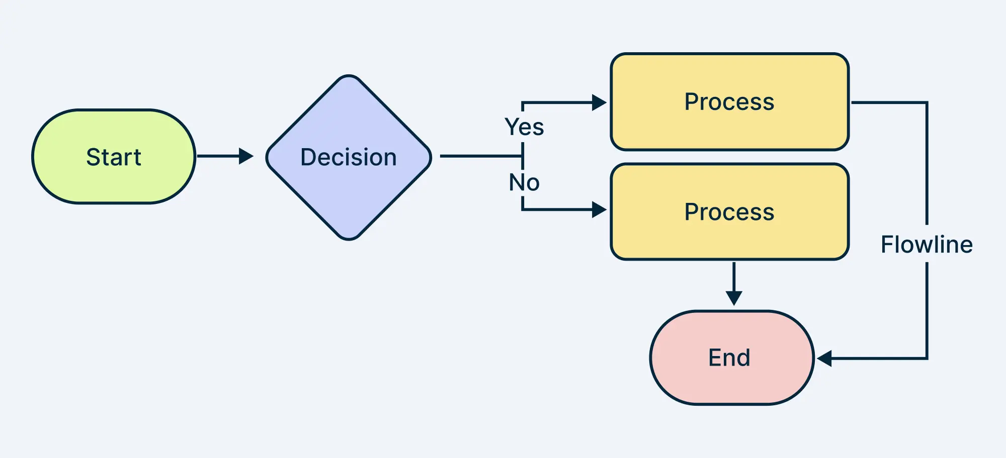

However, games are different—they need to run **continuously**, responding to player input, game events, and physics updates. This game loop will only stop when some quit condition is true, e.g. the player quits the game.

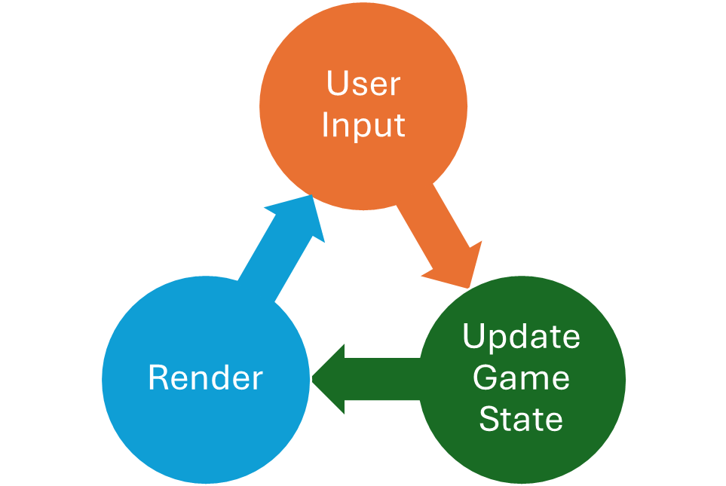

When running a game in the Unity Editor, it manages everything, including executing the game loop.

But when a game is built into an executable (.exe), the **game runtime** takes over, independently handling game logic, physics, and rendering in a continuous loop, just as it did in the Editor, but without all the Unity Editor development tools.

**MonoBehaviour** is a core part of this process.

**What is MonoBehaviour?**

Remember that a GameObject’s behaviour (what it does or how it appears in the game) is determined by the components it has.

For example, a GameObject’s position is set by its Transform component.

For a script to act as a component which can be attached to a GameObject, it must inherit from MonoBehaviour.

MonoBehaviour is the *base class* for all scripts in Unity. If a script does not inherit from MonoBehaviour, Unity won't be able to add it as a component and execute it as part of a GameObject's behavior.

Without MonoBehaviour, your script is just a regular C# class—it exists, but Unity doesn’t know when or how to use it.

**MonoBehaviour and the Game Loop**

A script that inherits from MonoBehaviour and is attached as a component to a GameObject automatically connects to Unity’s game loop.

But how?

When you press the play button in the Unity Editor, or start an exe file to play a game, the game runtime (we’ll just call it the *runtime* from here) loads all GameObjects in the scene, and then checks for all the components each GameObject has.

If a GameObject has a script component, the runtime automatically calls each component’s lifecycle methods at the correct times. First, it runs **Awake()** (if defined), then **Start()**, and then continuously calls **Update()** every frame. This happens because Unity tracks and manages all MonoBehaviour scripts, ensuring they are executed as part of the game loop.

What are these lifecycle methods?

**Key MonoBehaviour Methods and When They Run**

|  |  |  |
| --- | --- | --- |
| **Method** | **When It Runs** | **Example in a Game** |
| Awake() | Before anything else | Loading a save file when the game starts |
| Start() | Once when object is enabled | Setting a player's starting health |
| Update() | Once per frame | Making a character move when pressing a key |
| FixedUpdate() | At fixed time intervals | Handling physics (e.g., making a ball fall smoothly) |
| LateUpdate() | After Update() | Adjusting the camera position after the player moves |

These are automatically called by the runtime.

When you right-click in the Assets folder (or subfolder) and select **Create /MonoBehaviour Script**, unity creates a new C# file from a template which has the **Start** and **Update** functions defined:

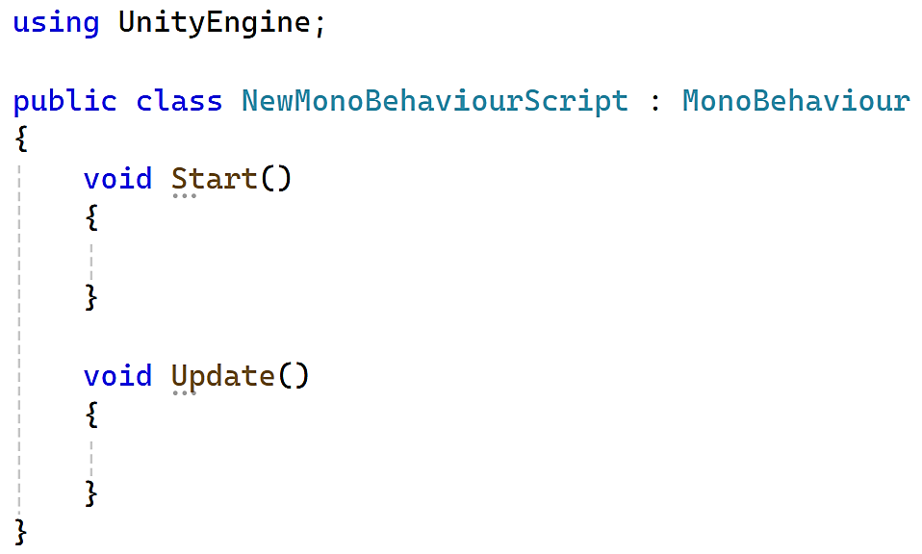

Why these functions?

Because they are the core functions most scripts need:

* **Start**: Automatically called only once when the GameObject is created. This is used to run any intial setup code for the GameObject.
* **Update**: Automatically called every frame. This is used to specify any changes that the GameObject makes to itself or the game every frame, e.g. moving an asteroid sprite across the screen.

Let’s look at a few examples.

**Titan-01: Initializing Combat Systems**

Before Titan-01 can enter battle, its core systems must be activated. This doesn’t happen instantly—there’s a precise sequence that the runtime follows to bring everything online.

When you press Play in the Unity Editor or start the game’s .exe, the runtime loads all GameObjects in the scene and checks for their components.

If a GameObject has a MonoBehaviour script, the runtime automatically calls its lifecycle methods in order, ensuring that systems come online smoothly.

For Titan-01, this means:

* **Awake() – Boot Sequence** → Runs **immediately**, even before the game starts. Used for low-level setup, like loading critical data.
* **Start() – Systems Online** → Runs **once** after Awake(), when Titan-01’s power core is stable. Used for initialization.
* **Update() – Continuous Operation** → Runs **every frame**, monitoring energy levels, weapon status, scanning for threats, etc.

Let’s get Titan-01 up and running!

1. Create a new folder called **03 Unity Scripting/MonoBehaviour**.
2. Create a new empty GameObject called **Titan**.
3. Create this script and add it as a component to the Titan GameObject:

using UnityEngine;

public class TitanLifecycle : MonoBehaviour

{

    void Awake()

    {

        Debug.Log("Titan-01: Initial boot sequence initiated.");

    }

    void Start()

    {

        Debug.Log("Titan-01: Power core stable. Ready for action.");

    }

    void Update()

    {

        Debug.Log("Titan-01: Scanning for threats...");

    }

}

1. Run the project. You will see these messages in the console:

Note the sequence of messages:

1. from Awake()
2. from Start()
3. from Update()

The last message never stops. Why not?

Remember the game loop? This is a loop that never ends until the game quits. Every time round the loop, the runtime will call the **Update** function of every component in the game.

So the TitanLifecycle component’s Update function will be called every time around the loop, i.e. every frame.

**Exercise 1**

Modify the script to add these methods and their outputs:

* FixedUpdate() → "Titan-01: Running periodic stability checks."
* LateUpdate() → "Titan-01: Adjusting targeting systems."



Of course, this is just a fun storyline for your worksheet, but why do you think “Running periodic stability checks" is a suitable message for FixedUpdate, and “Adjusting targeting systems” for LateUpdate? Delete this text and type your answer here.

Before continuing, put your hand up to explian your answer to your tutor, or to get some help if you’re not sure.

**Exercise 2**

Disable the TitanLifecycle script from Exercise 1.

Create a new script.

using UnityEngine;

public class GameLoopTest : MonoBehaviour

{

    private float lastFixedUpdateTime;

    private float lastUpdateTime;

    private float lastLateUpdateTime;

    void FixedUpdate()

    {

        float deltaTime = Time.time - lastFixedUpdateTime;

        lastFixedUpdateTime = Time.time;

        Debug.Log($"FixedUpdate: {deltaTime:F4}s since last call.");

    }

    void Update()

    {

        float deltaTime = Time.time - lastUpdateTime;

        lastUpdateTime = Time.time;

        Debug.Log($"Update: {deltaTime:F4}s since last call.");

    }

    void LateUpdate()

    {

        float deltaTime = Time.time - lastLateUpdateTime;

        lastLateUpdateTime = Time.time;

        Debug.Log($"LateUpdate: {deltaTime:F4}s since last call.");

    }

}

Don’t worry about the details of the script for now. It’s a way to compare the number of seconds since each of the update methods was last called.

When you run the project, you should see something like this:

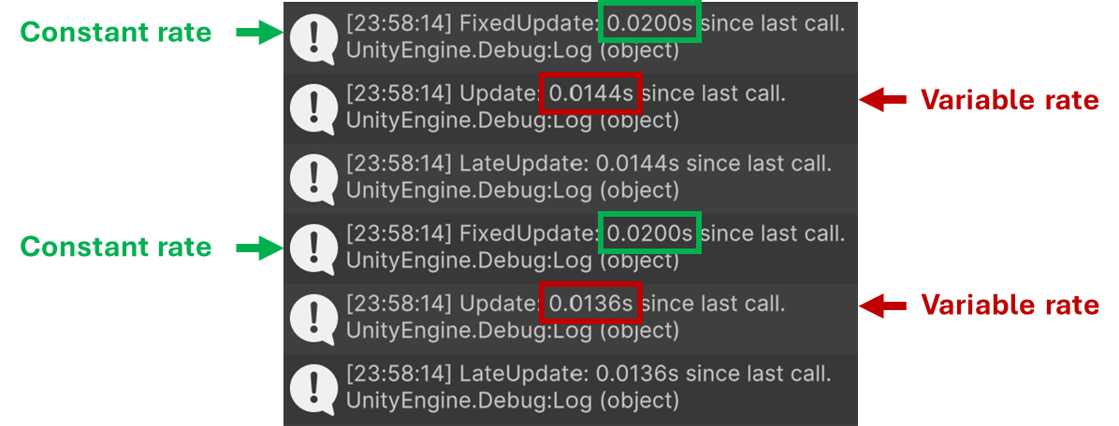

Note that **FixedUpdate** is called at a *fixed* rate, every 0.02 seconds.

But **Update** is called at a *variable* rate.

From the earlier table, remember that Update is called every frame. But this means that the game’s framerate is variable!

This makes sense, since a game’s fps often drops. This is usually when the game has some intensive processing to do, like rendering a complex scene or handling complex physics interaction between a large number of objects.

Later, you’ll see that this is very important when we explore Unity Physics. For physics to run smoothly, the object interactions must be updated at a constant rate. This is why physics code is put inside a script’s FixedUpdate method.

**Complex Example**

Now let’s look at a more complex example. We’ll create a simple sprite object that displays the Titan, and add a script. The script’s lifecyle methods (Awake, Start, Update) will have the following functionality:

* **Awake**: Give the sprite a slight red tint to indicate that it has been configured.
* **Start**: Increase the sprite size to indicate that it is ready for action.
* **Update**: Move the sprite left to right continuously, as if patrolling.

You’ll create the sprite and script.



Don’t worry if you don’t understand all the code.

We just want to illustrate how the Awake, Start, and Update functions work.

1. Download **Titan.png** from LMS and import it into your project. Create an **Images** folder if you have’t already done so and put the image there.

Select the image, and in the Inspector set the import settings to:

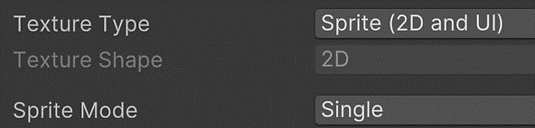

1. Drag the image into the Hierarchy to create a GameObject called **Titan 01**. Remember to **reset** its transform values to position it at the origin (0,0,0).

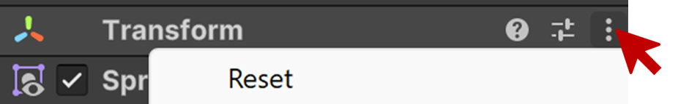

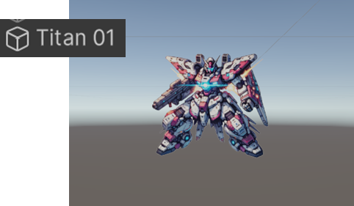

1. Create a new class and attach it as a component to **Titan 01** .

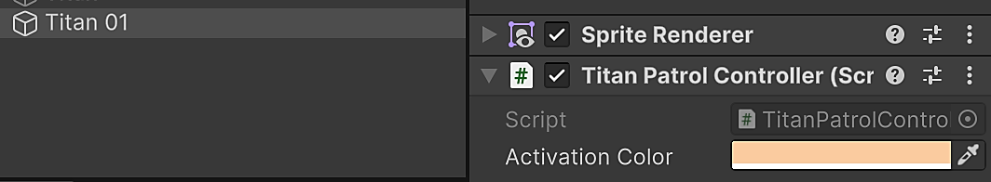

using UnityEngine;

public class TitanLifecycleVisual : MonoBehaviour

{

public Color activationColor;

}

This doesn’t do anything yet.

But note that **activationColor** is of tyoe **Color**. This is a Unity class that represents a colour. Since it is declared public, it appears in the Inspector. You can set it using a color picker!

1. We want to change the sprite colour in Awake, so we need a reference to the GameObject’s SpriteRenderer component. But first, we must declare it:

private SpriteRenderer spriteRenderer;

1. Now add the Awake method.

void Awake()

{

    spriteRenderer = GetComponent <SpriteRenderer>();

    spriteRenderer.color = activationColor;

    Debug.Log("Awake: Titan-01 is configured.");

}

Run the project.

You should see the **Titan 01** sprite take on a red tint (or whatever colour you chose in the colour picker). This is just to indicate that the Titan has been switched on (become *awake*).

The message should also be output to the console.



1. Add a Start method.

void Start()

{

    // Scale up the sprite’s width and height to 1.25 times.

    transform.localScale = new Vector3(1.5f, 1.5f, 1.0f);

    Debug.Log("Start: Titan-01 scaled for action.");

}

The **Titan 01** GameObject will be scaled 1.25 times along its width and height (x and y axes). This is just to indicate the the Titan is ready for action (its engine has *started*, so to speak).



The message should also be output to the console.

1. Add an Update method.

void Update()

{

    // Move left and right to simulate patrolling

    transform.position += new Vector3(direction * moveSpeed * Time.deltaTime, 0, 0);

    // Check if the sprite needs to change direction

    if (Mathf.Abs(transform.position.x - startPos.x) >= moveLimit)

    {

        direction *= -1; // Reverse direction

    }

    Debug.Log("Update: Titan-01 patrolling...");

}

Update makes use of **direction**, **moveSpeed**, **moveLimit** and **startPos** variables, so these need to be declared!  
  
Add these to the top of the class:

private float moveSpeed = 2f;  // Speed of horizontal movement

private float moveLimit = 3f;  // Maximum distance from start pos

private Vector3 startPos;

private int direction = 1;  // 1 = right, -1 = left

The sprite will now patrol left and right.



The message should also be output to the console.

This exercise showed how **MonoBehaviour lifecycle methods** affect a GameObject in Unity.

* **Awake()** runs first and is used for **initial setup**—in this case, changing the sprite’s color.
* **Start()** runs next and is used for **initial activation**—scaling up the Titan to show it’s ready.
* **Update()** runs continuously, allowing the Titan to **patrol left and right** each frame.

By seeing clear visual changes (color, size, movement), you now understand how Unity calls these methods automatically and why they are essential for controlling GameObjects.

In future scripts, you’ll use these methods to initialize objects, trigger animations, handle input, and update gameplay mechanics.

Okay, so far we’ve looked at:

* **The Unity Game Loop** – How Unity continuously updates game logic, physics, and rendering every frame.
* **What is MonoBehaviour?** – How it allows scripts to be attached to GameObjects and executed automatically.
* **Game Runtime vs. Editor** – The difference between running a game in the Unity Editor and as a built .exe.
* **MonoBehaviour Lifecycle Methods** – Awake(), Start(), Update(), FixedUpdate(), and LateUpdate(), and when they run.
* **Titan-01 Activation Sequence** – How MonoBehaviour methods simulate bringing a mech online step by step.
* **Lifecycle Order** – Running a script to see Awake(), Start(), and Update() in the Console.
* **FixedUpdate vs. Update Timing** – Measuring how often these methods are called to understand their timing differences.
* **Frame Rate Variability** – Why Update() runs at a variable rate depending on performance, while FixedUpdate() runs at a fixed interval (which is why physics code is put here).

Now that you know what the MonoBehaviour class is, you can continue in the next worksheet to build on your knowledge of how Unity works to write scripts that modify GameObjects as your game runs.

It’s important that you understand all the concepts here!

Don’t just ask your friends or Chat GPT to tell you what to do—if so, you’ll hit bigger problems during your GADV project and your later subjects such as Game AI and Maths & Physics Programming!

If you need any help, ask your tutor 😊

**Suggested Resources**

You should look for your own tutorials and resources, but here are a few good links for you to explore.

* Unity [MonoBehaviour](https://docs.unity3d.com/6000.0/Documentation/ScriptReference/MonoBehaviour.html) documentation

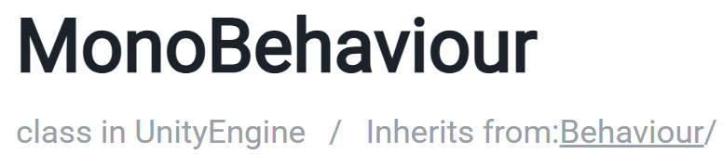

While Unity is component based, this is mostly the scripting architecture (how you write your scripts). But Unity and the Unity API itself follows object-oriented programming principles. The Unity documentation gives a good idea of how the various classes are related.

* [StackOverflow](https://stackoverflow.com/questions/41630986/what-is-monobehaviour-in-unity-3d)

A few good responses to the question: *What is MonoBehaviour in Unity 3D?*

“MonoBehaviour is the base class from which every Unity script derives. It offers some life cycle functions that are easier for you to develop your app and game.”

* [Reddit/Unity3D](https://www.reddit.com/r/Unity3D/comments/15h91wb/unity_monobehaviour_vs_c_classes/): *Unity MonoBehaviour vs C# classes*

Some good responses to the age-old debate about how much to use Unity MonoBehaviour-based components vs. plain ole C# classes. This discussion is slightly more advanced, concerned with software design principles and best practices, which we’ll cover later once you get to grips with the basics. But it’s good to have a look at such issues in advance.

* [Guide to MonoBehaviour in Unity](https://www.sharpcoderblog.com/blog/guide-to-monobehaviour-in-unity)

A good overview of MonoBehaviour.

“MonoBehaviour is a base class for all Unity scripts that provides a wide range of built-in functionality for controlling game objects, responding to player input, controlling the rendering, and many more.”

* [Tarodev](https://www.youtube.com/watch?v=xPg5H4FX9_c): MonoBehaviour? Let me teach you

Tarodev is a good, straightforward Unity YouTube tutorial channel. You should take some time to explore the playlists (we’ll refer to some of these during GADV).

